**21.b.)Update a Column When the Total is Above 80 is Distinction,Above 60 is First Class,Above 50 is Second Class.**

**CREATE TABLE Stu_det (**

**stu_id INT PRIMARY KEY,**

**stu_name VARCHAR(100),**

**stu_dep VARCHAR(100),**

**dep_id INT**

**);**

**INSERT INTO STU_DET VALUES(1,'Abhilaash','CSE',10);**

**INSERT INTO STU_DET VALUES(2,'Ajmal','CSE',10);**

**INSERT INTO STU_DET VALUES(3,'harsha','CSE',20);**

**INSERT INTO STU_DET VALUES(4,'Aadharsh','CSE',30);**

**INSERT INTO STU_DET VALUES(5,'Sriram','AIDS',40);**

**INSERT INTO STU_DET VALUES(6,'Prashanth','ECE',50);**

**INSERT INTO STU_DET VALUES(7,'Prakash','EcE',60);**

**SELECT *FROM STU_DET ORDER BY STU_ID;**

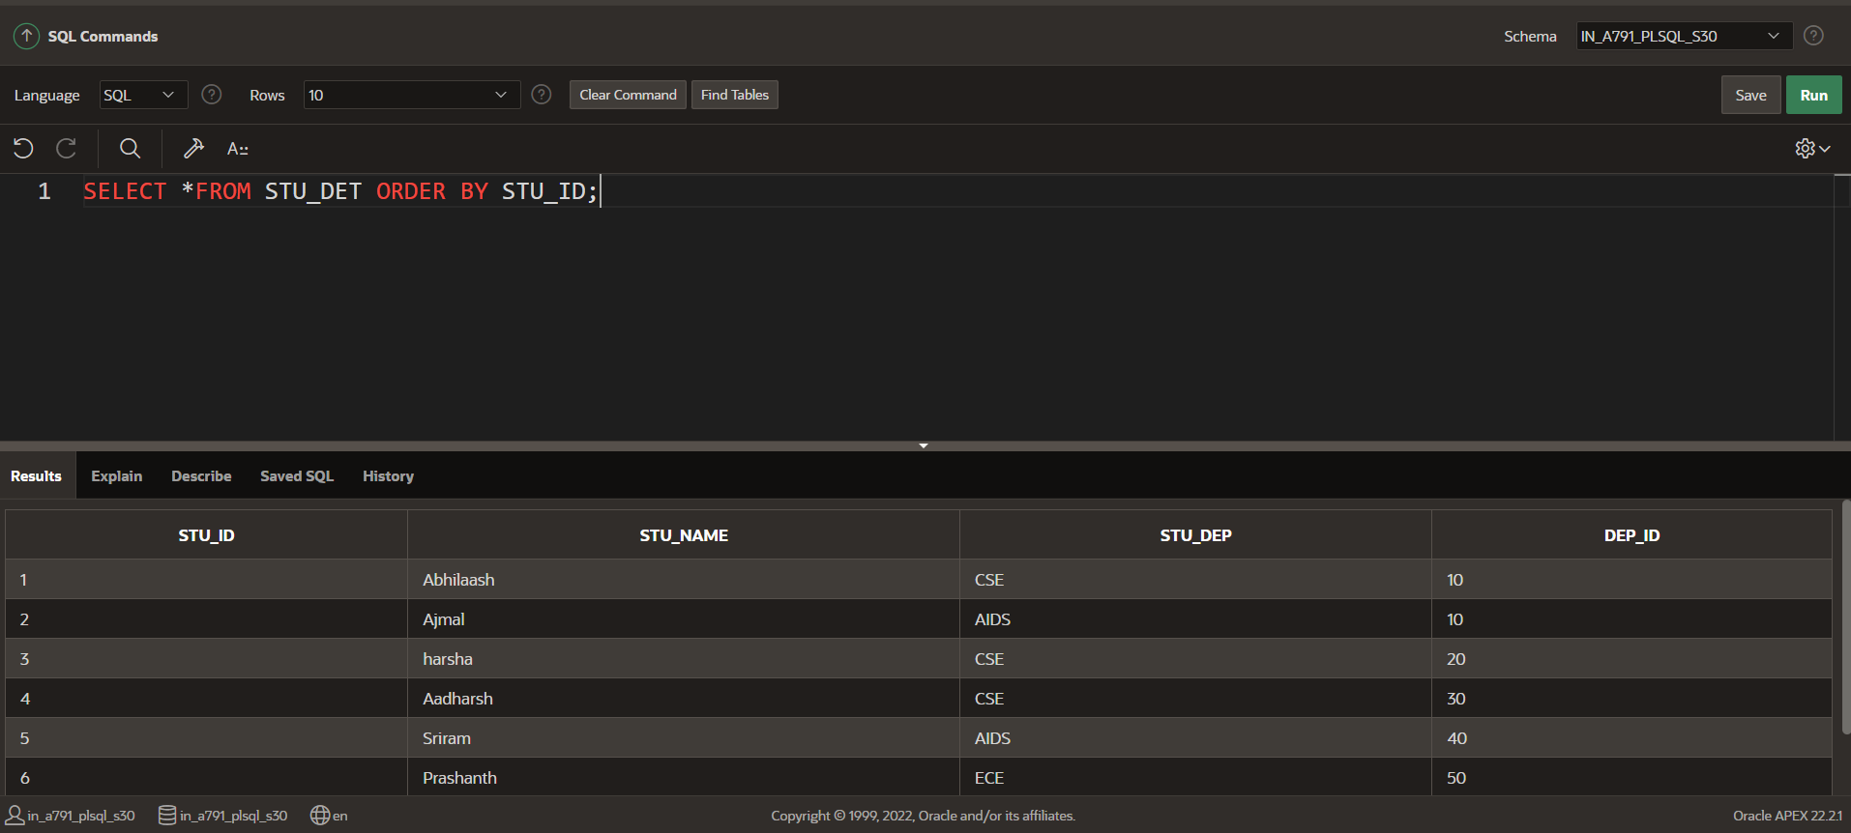

**CREATE TABLE M_D(stu_id INT,Total_mark INT,Grade VARCHAR(20),FOREIGN KEY (stu_id) REFERENCES Stu_det(stu_id));**

**INSERT INTO M_D VALUES(1,81,'DISTINCTION’);**

**INSERT INTO M_D VALUES(2,88,' DISTINCTION ');**

**INSERT INTO M_D VALUES(3,65,'FIRST CLASS');**

**INSERT INTO M_D VALUES(4,58,'SECOND CLASS');**

**INSERT INTO M_D VALUES(5,45,'FAIL');**

**INSERT INTO M_D VALUES(6,75,'FIRST CLASS');**

**INSERT INTO M_D VALUES(7,41,'FAIL');**

**SELECT *FROM M_D ORDER BY STU_ID;**

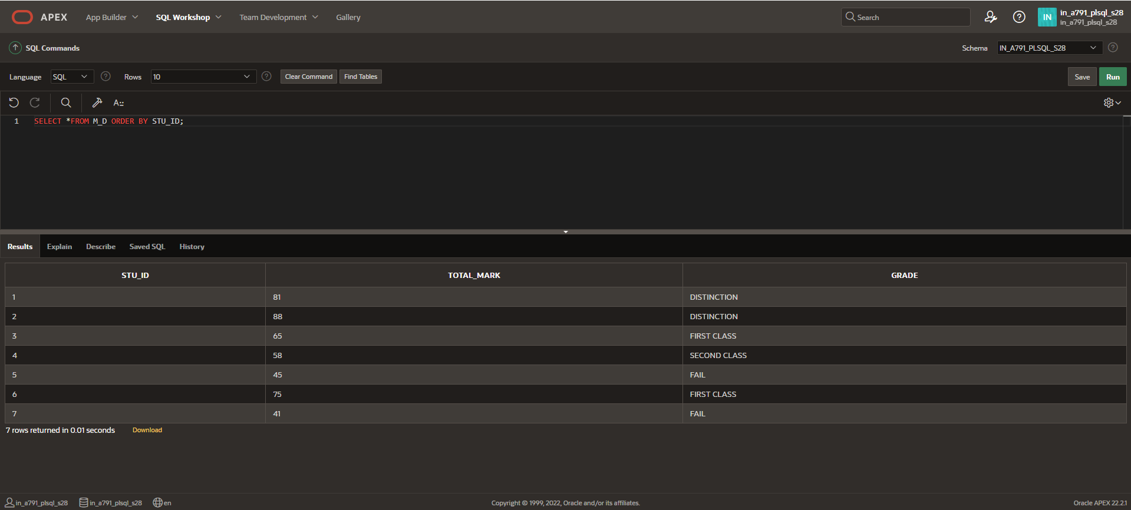

**User-defined Records**

**DECLARE**

**TYPE STUDENT_MARK_DETAILS IS RECORD (**

**STU_ID Stu_det.stu_id%TYPE,**

**STU_NAME Stu_det.stu_name%TYPE,**

**TOTAL_MARK M_D.Total_mark%TYPE,**

**GRADE M_D.Grade%TYPE**

**);**

**v_student_mark_details STUDENT_MARK_DETAILS;**

**BEGIN**

**SELECT s.stu_id, s.stu_name, m.Total_mark, m.Grade**

**INTO v_student_mark_details**

**FROM Stu_det s**

**JOIN M_D m ON s.stu_id = m.stu_id**

**WHERE s.stu_id = 6;**

**DBMS_OUTPUT.PUT_LINE('Student ID: ' || v_student_mark_details.STU_ID || ', Name: ' || v_student_mark_details.STU_NAME || ', Total Mark: ' || v_student_mark_details.TOTAL_MARK || ', Grade: ' || v_student_mark_details.GRADE);**

**END;**

